
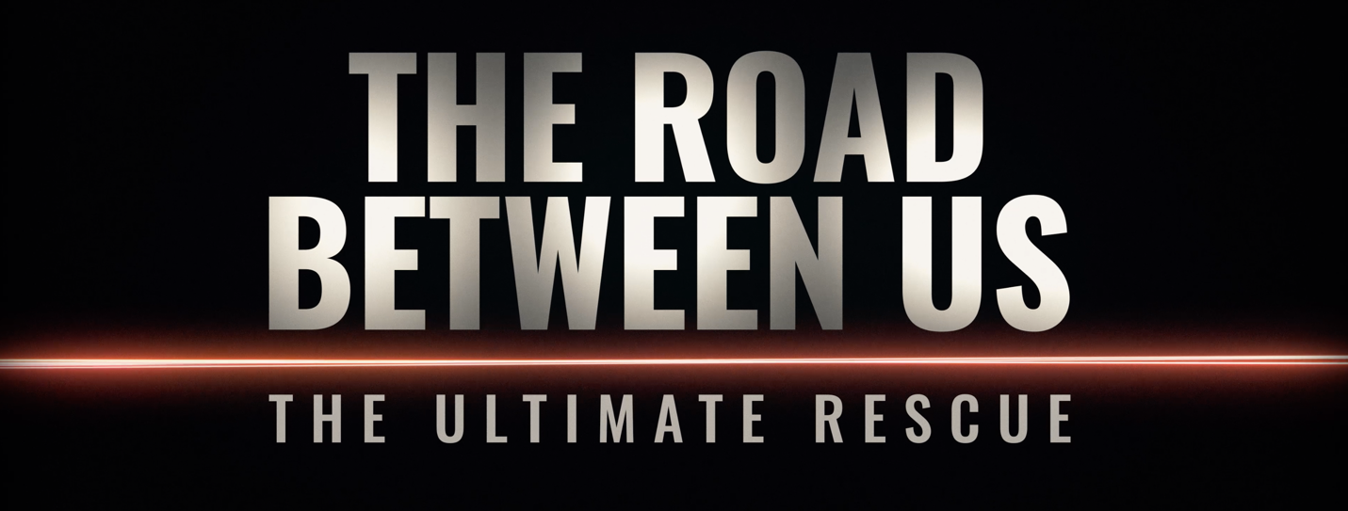
PRESS NOTES



A FILM BY BARRY AVRICH, the director of:
Born Hungry (2024)
Without Precedent: The Supreme Life of Rosalie Abella (2023)
The Talented Mr. Rosenberg (2022)
Oscar Peterson: Black + White (2021)
Made You Look: A True Story About Fake Art (2020)
David Foster: Off the Record (2019)
Prosecuting Evil: The Extraordinary World of Ben Ferencz (2018)

WORLD PREMIERE
Wednesday, September 10, 2025 - 6:00 PM – TIFF Lightbox Cinema 1 (Public 1)
Thursday, September 11, 2025 - 11:30 AM - TIFF Lightbox Cinema 3 (Public 2)
Thursday, September 11, 2025 - 8:30 AM - TIFF Lightbox Cinema 3 (Press & Industry)

Press Contact
Laila Ismail / The TARO Group – 437-499-1407 – laila@thetarogroup.com
Melbar Entertainment Group
in association with
Loft Entertainment
and
Sheldon Inwentash & Lynn Factor
present

THE ROAD BETWEEN US:
THE ULTIMATE RESCUE

Director: Barry Avrich
Writer: Barry Avrich
Executive Producers: Sheldon Inwentash, Lynn Factor, Barry Avrich,
Randy Lennox, Jeffrey Latimer
Producers: Mark Selby, Barry Avrich p.g.a.
Line Producer: Talia Harris Ram
Editor: Dave Kennedy
Music: Michael A. Perlmutter, GMSC
Original Score: Mark Selby
Cinematographer: Ken Ng
Art Director: Nick Sewell
Cast: Noam Tibon, Gali Mir-Tibon, Amir Tibon, Miri Tibon,
Beri Meirovich, Sharon Fiorentino, Nissan Dekalo
Year: 2025
Run Time: 95 minutes
Country: Canada
Language: English
Production Company: Melbar Entertainment Group Inc.

High-res photos available on request

Trailer: [COMING SOON]

Instagram:
@barryavrich22
@markselby

Melbar Entertainment Group:
www.melbarentertainment.com

LOGLINE

A former decorated general comes out of retirement and uses all his extensive military training to rescue his son, daughter-in-law, and two young granddaughters whose home has been surrounded and attacked by terrorists.

SYNOPSIS

In what could have been inspired from films such as Taken or Extraction, retired decorated general Noam Tibon receives a desperate sounding early morning text message on October 7, 2023. His son informs his father that his home has been invaded by terrorists; the son, his wife, and their two small children under the age of 5 fear their imminent death.

For the next ten hours, using his skills and experience, Noam and his wife, Gali, embark on a harrowing, edge-of-the-seat mission to try and save their family. Along the way, they hurtle through harrowing and violent ambushes at a breathless velocity with only one thing on the mind: saving their family before they are slaughtered.

The Road Between Us takes Noam Tibon back on the very same route he drove to save his family, and in extraordinary, gritty detail, recounts the very worst and best day of his life.

DIRECTOR’S STATEMENT

What would you do if your family was seconds away from being exterminated?

This documentary is not a political statement but a no-holds-barred, family-driven action film that will have audiences on the edge of their seats.

Noam Tibon is a born storyteller in an action hero kind of way, and this film seamlessly weaves his experience and heroic journey as we retrace his mission to save his family. As we travel the roads he took to get to them, we juxtapose actual Hamas invasion footage with new and raw storytelling from Noam and his family.

We experience his provocative story from the wars that trained him to be ready for this unspeakable day of horror. This film is riveting: part James Bond, Rambo, and Liam Neeson, this is the most daring and thrilling rescue story ever told.

- Barry Avrich

BIOS

NOAM TIBON – Subject
Major General (Res.) Noam Tibon served in the Israel Defense Forces (IDF) for 35 years, specializing in combat operations and counterterrorism. He began his distinguished military career in the IDF special forces and later held a number of senior command positions, including commander of the 202 Paratroopers Battalion, the Nahal Brigade, and the West Bank Division.
His last position was commander of the Northern Formation, where he was responsible for securing Israel’s northern border with Lebanon. Major General Tibon is one of Israel’s top experts on counterterrorism, a field on which he has advised local and international companies since his retirement from the IDF in 2015. Today, Tibon works to create employment opportunities for Arab citizens of Israel and Palestinians in the Israeli high-tech industry.
Major General Tibon holds an M.A. degree in public administration from Harvard University and a B.A. degree in history (Summa Cum Laude) from Haifa University in Israel. He is also a graduate (Summa Cum Laude) of the U.S. Marine Corps Command and Staff College.

BARRY AVRICH – Director, Writer, Executive Producer, and Producer

Veteran producer and award-winning director Barry Avrich is the creative force behind Melbar Entertainment Group, one of the largest producers of non-scripted content in North America. Barry has produced and directed over 60 documentaries and filmed productions including the internationally acclaimed Born Hungry, Without Precedent: The Supreme Life of Rosalie Abella, The Talented Mr. Rosenberg, The Last Mogul, Prosecuting Evil, David Foster: Off the Record, and Oscar Peterson: Black + White, which premiered at the 2021 Toronto International Film Festival. He has produced over twenty award-winning stage-to-screen adaptations of Broadway and Shakespeare productions including The Tempest with Christopher Plummer and King Lear with Colm Feore.

He recently released The Devil Wears Rothko, a book based on his acclaimed documentary Made You Look; Barry released his best- selling memoir, Moguls, Monsters and Madmen, in 2017. Avrich also built the world's first movie theatre in a hospital at Sick Kids in Toronto.

MARK SELBY – Producer, Original Score

Mark Selby is an award-winning producer specializing in live comedy/variety, long-form documentary, and high-profile events, with a focus on collaborations with the best established and emerging talent. He won two Canadian Screen Awards for Oscar Peterson: Black + White (Bell Media / Hulu), which received its world premiere at the 2021 Toronto International Film Festival. Additional documentary credits include Born Hungry (Tribeca Films / Palm Springs 2024 / Hot Docs 2024); Without Precedent: The Supreme Life of Rosalie Abella (CBC / PBS / Hot Docs 2023); The Talented Mr. Rosenberg (CBC / Hot Docs 2022); and Howie Mandel: But Enough About Me (Bell Media / Peacock).

Recent TV variety credits include annual live primetime special for the Giller Prize; the CBC music special FreeUp! Emancipation Day; screen adaptations of three Stratford Festival productions: Shakespeare’s Much Ado About Nothing, Richard III, and Edward Albee’s Three Tall Women; and From Ontario With Love, a live all-star New Year’s Eve TV concert.

Mark has also programmed live comedy for the Stratford Festival and Just For Laughs, and produced top-rated specials for the legendary Air Farce comedy troupe. www.markselby.ca

PRODUCTION COMPANY

MELBAR ENTERTAINMENT GROUP
Melbar Entertainment Group was established in 1998, by veteran producer and award-winning director Barry Avrich and has become one of the largest producers of non-scripted content in North America. Avrich and partner Mark Selby have produced and directed over 70 documentaries and filmed productions including the internationally acclaimed Made You Look, Born Hungry, The Last Mogul, Prosecuting Evil, David Foster: Off The Record, Oscar Peterson: Black + White, 22 award-winning stage-to-screen adaptations of Broadway and Shakespeare productions including The Tempest with Christopher Plummer and King Lear with Colm Feore and many live productions such as the Giller Prize and the Canadian Screen Awards. In 2017, Barry's best-selling memoir, Moguls, Monsters and Madmen, was released, and in 2025, Barry published The Devil Wears Rothko.

