Documist
presents
NUISANCE BEAR
A short documentary
by Jack Weisman and Gabriela Osio Vanden

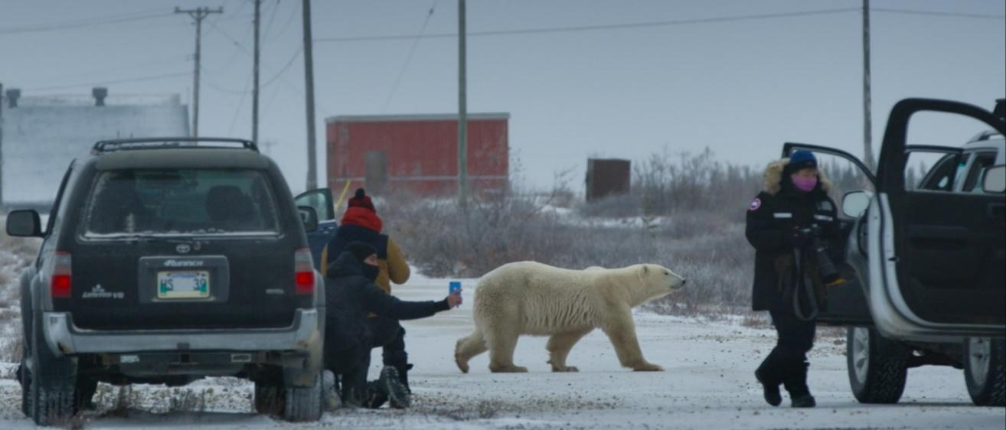

World Premiere at TIFF 2021 in Short Cuts

Media Contact
Virginia Kelly
V Kelly & Associates
info@vkpr.ca

NUISANCE BEAR Press Notes

Country of origin: Canada
Production year: 2021

Production company: Documist

Running time: 14 minutes

Trailer: available on request

Clip: available on request

Hi-Res photos: available on request

SOCIAL MEDIA

Hashtags: #TIFF21 #TIFFShortCuts #documist #nuisancebearfilm #femaledirector #victorysocialclub #documentary #canadianarctic #polarbear #churchillmanitoba #wildlifefilmmaking
Jack Weisman
Instagram: www.instagram.com/jack_weisman/
Website: www.jackweisman.com

Gabriela Osio Vanden
Instagram: www.instagram.com/sanguinuss/
Website: www.gabrielaosio.com/

Documist
Facebook: https://m.facebook.com/documist/
Instagram: www.instagram.com/documist/
Website: www.documist.com

NUISANCE BEAR Press Notes

SHORT SYNOPSIS

Churchill, Manitoba is famous as an international destination for photographing polar bears. We’ve seen the majestic images and the classic wildlife TV programs – but what does the bear see of us? Jack Weisman and Gabriela Osio Vanden’s unconventional and visually arresting Nuisance Bear shifts the perspective for a revealing look at a day in the life of a polar bear as it navigates an obstacle course of tourists and conservation officers. Nuisance Bear highlights the increasingly narrow and treacherous boundary between human and animal realms, asking audiences to consider the ways in which we interact with wildlife and if these relationships are sustainable.

SYNOPSIS
Churchill, Manitoba is a small community of 900 along the western shores of Hudson’s Bay whose economy depends on the 10,000+ tourists who descend each fall to catch a glimpse of polar bears during their annual migration. Local conservation officers are tasked with protecting the town from polar bears who are becoming increasingly desensitized to humans.
In Nuisance Bear, all eyes are on the polar bear as it lumbers past paparazzi, evading conservation trucks that intercept its path. As a helicopter pursues from above, the chase is punctuated with the thunder of flash bangs, all efforts to thwart the bear’s scavenging food from town.
But what does the bear see of us as it traverses this human-made obstacle course? Filmmakers Jack Weisman and Gabriela Osio Vanden’s unconventional and visually arresting Nuisance Bear shifts the perspective for a revealing look at a day in the life of a migrating polar bear. The film is a compilation of moments not traditionally seen as valuable by wildlife photographers and television producers. Following Weisman and Osio Vanden’s vision, the film adheres to a muted aesthetic; stripped to essentials without interviews, voice-over, or music, with the goal of remaining close to the bear. Nuisance Bear is a reminder that animals express profound emotional complexity without the use of a full orchestra and omniscient narrator.

NUISANCE BEAR Press Notes
DIRECTORS’ STATEMENT

In 2015 we went to Churchill, Manitoba to shoot White Circus, a student film about polar bears. We were bewildered by the carnival-like atmosphere with photographers and tourists jockeying to see polar bears up close, while conservation officials walked a tightrope to create distance between humans and wildlife.

The experience made a lasting impression as we scrambled to make sense of it all. Growing up watching shows like Planet Earth, we didn’t question their veracity. After visiting Churchill, our experience on the ground no longer matched what those programs showed us and we began to examine our preconceived notions of how wildlife is documented.

We continued visiting the North every year, and we began to understand how many complex stories are being omitted, or refracted to suit a pre-formed narrative. As working cinematographers documenting an experience, we ask ourselves, what does it mean to point a camera? What is our relationship to power as an observer? The more time we spent there, the more strongly we wanted to produce something that is an honest depiction of everyday reality.

To tell complicated human stories authentically takes time, commitment, and trust, especially as Southern filmmakers, so we began to think of this as a longer-term project. We see Nuisance Bear as the first in a series of vignettes about the interplay between humans and polar bears, and an initial step towards a feature documentary.

Nuisance Bear is a compilation of moments not traditionally seen as valuable by wildlife photographers and television producers. Our film adheres to a muted aesthetic; stripped to essentials without interviews, voice-over, or music, with the goal of remaining close to the bear. Nuisance Bear is a reminder that animals are still capable of expressing profound emotional complexity without the use of a full orchestra and omniscient narrator.

Climate change is no longer an abstract idea. Its consequences are unfolding in real-time. Polar bears are adapting to what we impose on them. We hope this film asks audiences to consider the ways in which we interact with wildlife and if these relationships are sustainable.

NUISANCE BEAR Press Notes

Q&A

Why is the film called Nuisance Bear?
A nuisance bear is any bear that is considered unwelcome. It can also mean a bear that has lost its fear of humans. There are many different ideas in Churchill about what makes a bear unwelcome and merits removal. Nuisance bears are often young bears who are still learning how to find food or mothers with cubs.

Why did you make this film?
In Churchill, tourism and Manitoba Conservation work at cross-purposes. Tour operators offer to bring humans as close to bears as possible while conservation officers’ mandate is to protect human lives and prevent the habitation of bears to humans. We’re motivated to explore this dynamic that’s critical to the future of wildlife in the North.

How did you make this film?
We felt strongly we needed to tell this story from the bear's perspective. In order to do this, we engineered a rig that would allow us to mount a camera and long telephoto lens to the front of our car. This way we could control the camera from inside the vehicle and safely film moving polar bears at eye level. Not needing to exit the car and set up the tripod every time we wanted a shot meant we could move very quickly. This approach allowed us to capture the never-before-seen sequences in the film.

Is it one bear in the film or many?
The bear in this film is a composite of three or four bears. The editing reflects the order in which the shots were captured and the scenes unfolded with each bear. We’ve created a narrative but we haven’t fictionalized the events. All of the sequences in the film occur every bear season in Churchill.

What happens to the bear at the end of the film? (spoiler alert)
This bear is tranquilized and airlifted 30 kilometers north of Churchill in hopes that it will continue on its migration away from town. The ‘bearlift’ also serves as a photo opportunity for tourists and TV crews. Its effectiveness as a management technique is unclear.

Is the bear management program in Churchill safe for bears?
The answer to this depends on who you ask. Historically, problem bears in communities like Churchill were shot. Considering this, it’s easy to see why the current bear management program sees itself as an improvement.

NUISANCE BEAR Press Notes

Q+A cont’d…

Are polar bears endangered?
Polar bears are at significant risk from climate change. Presently, some subpopulations are in decline however most are stable. Even though these bears face a potentially existential threat, many communities in Canada that live with polar bears claim certain ENGOs and wildlife photographers have misled the public. The condition of polar bears is a heated and ongoing debate in Churchill and other northern communities.

NUISANCE BEAR – Press Notes
BIOGRAPHIES
Jack Weisman, Director, Nuisance Bear
Jack is an award-winning cinematographer and first-time director living in Toronto. His images have screened at major film festivals including Sundance, Hot Docs, SXSW, and Big Sky. His credits as cinematographer include When Two Worlds Collide (Best Debut Feature, Sundance 2016); Take a Walk on the Wild Side (2018, Canadian Screen Award for Best Short Documentary); and Prince’s Tale (Hot Docs Best Canadian Short, Audience Favorite Award 2018).

Jack is passionate about unique approaches to storytelling and unconventional characters that intersect with the natural world. He has a BFA in Film Production from York University (2015). The short documentary Nuisance Bear is his directorial debut.

Gabriela Osio Vanden, Director, Nuisance Bear
Gabriela is a cinematographer based in Toronto. With a background in visual arts and dance, she brings an intuitive sense to her work. Projects she’s collaborated on have premiered at TIFF, Hot Docs, and Camerimage, among others. Her thesis film Rambler, premiered at Camerimage and she was awarded an internship with Phedon Papamichael ASC GSC who she shadowed on Alexander Payne’s Downsizing. Gabriela has a BFA in Film Production from York University. The short documentary Nuisance Bear is her directorial debut.

NUISANCE BEAR

CREDITS

Directors:
Jack Weisman
Gabriela Osio Vanden

Producer:
Jack Weisman

Cinematography:
Gabriela Osio Vanden
Sam Holling
Jack Weisman

Editors:
Andres Landau
Will Miller
Jack Weisman

Sound Design:
David Rose

Field Producer:
Dennis Compayre

Colourist:
Zach Cox

Re-record Mixer:
James Bastable

