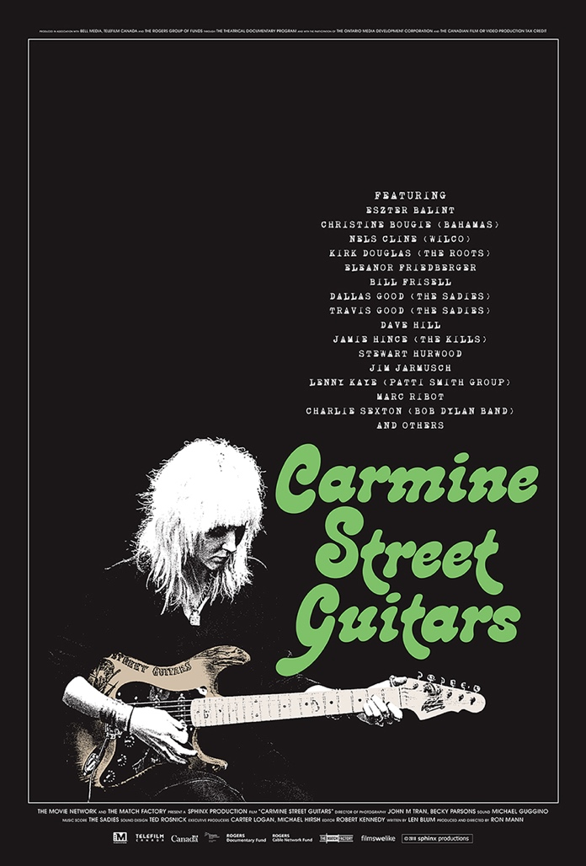

THE MOVIE NETWORK and THE MATCH FACTORY present
a SPHINX PRODUCTIONS film “CARMINE STREET GUITARS”
executive producers CARTER LOGAN, MICHAEL HIRSH
director of photography JOHN MINH TRAN, BECKY PARSONS
sound RECORDIST MICHAEL GUGGINO sound design TED ROSNICK
music score THE SADIES
editor ROBERT KENNEDY written by LEN BLUM
produced and directed by RON MANN

Produced in association with BELL MEDIA, TELEFILM CANADA and the ROGERS GROUP OF FUNDS through the THEATRICAL DOCUMENTARY PROGRAM and with the participation of the ONTARIO MEDIA DEVELOPMENT CORPORATION and the CANADIAN FILM OR VIDEO PRODUCTION TAX CREDIT
WITH
RICK KELLY, CINDY HULEJ, DOROTHY KELLY

FEATURING
ESZTER BALINT, CHRISTINE BOUGIE (BAHAMAS), NELS CLINE (WILCO), KIRK DOUGLAS (THE ROOTS), ELEANOR FRIEDBERGER, BILL FRISELL, DALLAS GOOD (THE SADIES), TRAVIS GOOD (THE SADIES), DAVE HILL, JAIME HINCE (THE KILLS),
STEWART HURWOOD, JIM JARMUSCH (SQÜRL), LENNY KAYE (PATTI SMITH BAND), MARC RIBOT, CHARLIE SEXTON (BOB DYLAN BAND)
4K / COLOR / 80 MIN

THE FILM

Once the centre of the New York bohemia, Greenwich Village is now home to lux restaurants, and buzzer door clothing stores catering to the nouveau riche. But one shop in the heart of the Village remains resilient to the encroaching gentrification: Carmine Street Guitars.

There, custom guitar maker Rick Kelly and his young apprentice Cindy Hulej, build handcrafted guitars out of reclaimed wood from old hotels, bars, churches and other local buildings. Nothing looks or sounds quite like a Rick Kelly guitar, which is the reason they are embraced by the likes of Bob Dylan, Lou Reed, Patti Smith, Jim Jarmusch, just to name a few.
Featuring a cast of prominent musicians and artists, the film captures five days in the life of Carmine Street Guitars, while examining an all-too-quickly vanishing way of life.

RICK KELLY

Long Island native Rick Kelly took his fascination toward trees one step further to break boundaries as a guitar builder. Growing up, Kelly had always idolized his grandfather as a woodworker. While in college studying sculpture, Kelly began collecting and working with ancient woods, noticing that the tones they conjured on the electric guitars he was building held deeper, resonant tones than those built on factory assembly lines. He eventually made his way to Greenwich Village where he opened up for business in the late 1970s before moving to the present storefront for Carmine Street Guitars in 1990.

A chance meeting with filmmaker Jim Jarmusch (who gave Kelly some wood from his loft to build him a guitar) led to Kelly’s discovery of New York timber: pine that had been lumbered in the Adirondacks’ virgin forests nearly two centuries ago for the construction of the neighborhoods of Lower Manhattan, the Village, Bowery, and what would become Soho and Tribeca. Reclaiming these “bones of the city,” Kelly commenced building electric guitars primarily modeled on Leo Fender’s classic Telecaster design.

RON MANN
Canadian filmmaker and producer Ron Mann is renowned for his genre-bending approach to documentary cinema that explores art forms and contemporary popular culture with vision and verve. From jazz (Imagine the Sound, 1981), spoken word (Poetry in Motion, 1982), comics (Comic Book Confidential, 1988), dance (Twist, 1992), marijuana (Grass, 1999), car culture (Tales of the Rat Fink, 2006), fungi (Know Your Mushrooms, 2009), and independent filmmaking (Altman, 2015) Mannʼs films invoke the ethos and spirit of his subjects in resonant and contemporary ways.

CAST

RICK KELLY
Rick Kelly took his love of woodworking one step further when creating guitars out of them. His handmade custom Telecasters have become the stuff of legend since he opened his store and workshop in Greenwich Village in the late1970’s, belying an industrious, gentle and earthy artisan with an eye for what an electric guitar should be and an ear for its enchanting sounds.

CINDY HULEJ
A native of Queens, New York, Cindy Hulej has always loved both music and art. She walked into Carmine Street Guitars five years ago and asked Rick for a job, and much to her surprise was hired on the spot.

DOROTHY KELLY
The 93-year-old matriarch of Carmine Street Guitars, Rick’s mother, Dorothy, has been crunching the numbers, keeping the books, and maintaining the shop. Mrs. Kelly’s role could not be filled by anyone else.

MUSICIANS

ESZTER BALINT
Singer-songwriter Eszter Balint is also an actress who made her cinematic debut in Jim Jarmusch’s Stranger Than Paradise.

CHRISTINE BOUGIE
Guitar and lap steel player, Christine Bougie is both a solo recording artist and guitarist in the indie band Bahamas.

NELS CLINE
Nels Cline is best known for his role as guitarist in the alternative rock band Wilco, as well as leading his own avant-garde jazz group.

KIRK DOUGLAS
“Captain” Kirk Douglas is the lead guitarist for the Hip Hop/Soul/Rock/Funk outfit The Roots, which performs as the house band for Late Night with Jimmy Fallon.

ELEANOR FRIEDBERGER
Singer-songwriter Eleanor Friedberger is also known for being half of the indie rock duo the Fiery Furnaces.

BILL FRISELL
A true innovator on his instrument, Bill Frisell is considered one of the world’s great jazz guitarists.

DALLAS AND TRAVIS GOOD
As well as prolific recording artists for The Sadies, the band also has backed the likes of Neko Case, Andre Williams and Neil Young.

DAVE HILL
Writer, DJ and stand-up comedian, Dave Hill is a member of the groups Valley Lodge and Painted Doll.

JAIME HINCE
Guitarist extraordinaire for indie rock duo The Kills, Jamie Hince lost the use of his middle finger in a freak accident, but that didn’t stop him from playing.

STUART HURWOOD
Long time guitar tech and friend of musician Lou Reed, Stuart Hurwood (in collaboration with Laurie Anderson) conceptualized the sonic installation Drones using Lou Reed’s amps and guitars.

JIM JARMUSCH
Film director, actor, and guitarist for his NYC band SQÜRL, Jim Jarmusch has been a guiding force of independent cinema since his breakout Stranger Than Paradise.
LENNY KAYE
Lenny Kaye is best known as Patti Smith’s guitarist from her debut to the present day. Possessed with an encyclopedic knowledge of music, history and culture, Lenny Kaye compiled the classic garage rock LP anthology Nuggets.

MARC RIBOT
Guitar virtuoso Marc Ribot has explored free rock/jazz guitar as a solo artist as well as collaborator with Tom Waits, Elvis Costello and Marianne Faithful among others.

CHARLIE SEXTON
Longstanding guitarist for Bob Dylan, Charlie Sexton is also an actor featured in the award-winning films Boyhood and Blaze.

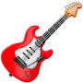

Download Press Kit, High-Rez Images, Clips For Broadcast
http://www.sphinxproductions.com/films/carmine-street-guitars

WORLD SALES
THE MATCH FACTORY
Brigitte Suarez
sales@thematchfactory.de
+49 221 539 70 9 0

MEDIA CONTACT CANADA
VKPR
Virginia Kelly
virginia@vkpr.ca

MEDIA CONTACT USA
Susan Norget Film Promotion
Susan Norget
susan@norget.com

OTHER INQUIRIES
FILMS WE LIKE
Michael Boyuk
mike@filmswelike.com
+ 1 416 971 9131

