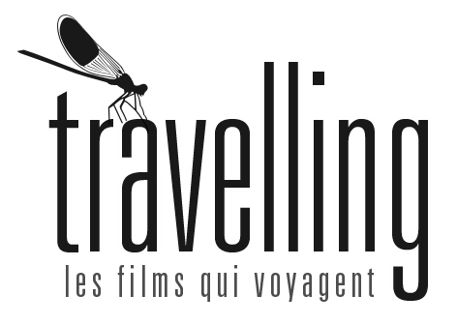
NO CRYING AT THE DINNER TABLE

Doc | 2019 | Canada | 15:40 min | 16:9 | HD | Color | Digital 5.1 | English+Vietnamese, with English subs

CAST

Thao Nguyen-Duong

Ngoc Nguyen

Michelle Nguyen

Carol Nguyen
CREW

Production : Carol Nguyen, Aziz Zoromba (Concordia Film School)
Director : Carol Nguyen
DoP : Walid Jabri
Production Design : Carol Nguyen
Editor : Carol Nguyen, Andres Solis
Sound: Giulio Trejo-Martinez, Tim Horler, Alex Lane
Music : Arie Van de Ven

Synopsis
Filmmaker Carol Nguyen interviews her family to craft a portrait of love, grief and intergenerational trauma.

Bio

Carol Nguyen is a Vietnamese-Canadian filmmaker based in Montreal. Carol is a TIFF Share Her Journey ambassador, an Adobe Creativity Scholar and a 2018 Sundance Ignite Fellow and an Adobe Creativity Scholar. Today, Carol is continuing her passion for filmmaking at Concordia University.

Carol Nguyen est une réalisatrice canadienne d'origine vietnamienne basée à Montréal. Carol est ambassadrice du programme Share Her Journey ambassador au TIFF, elle est boursière Adobe Creativity, de Sundance Ignite Fellow 2018 et boursière Adobe Creativity. Aujourd'hui, Carol poursuit sa passion pour le cinéma à l'Université Concordia.

Festivals
Toronto Int. Film Festival, Canada |2019| Official Competition
Vancouver Int. Film Festival, Canada |2019| Official Competition
Festival du Nouveau Cinéma, Montréal |2019| Official Competition
Real Asian Film Festival, Toronto |2019| Official Competition
RIDM, Montréal |2019| Official Competition
IDFA, The Netheralands |2019| Official Competition
South Western Int. Film Festival, Canada |2019| Official Competition
TIFF Shortcut Series: Portraits, Canada |2019| Official Screening
Calgary Underground Film Festival, Canada |2019| Official Screening
Cucalorus Film Festival, USA |2019| Official Competition
All Animals Are Equal, Vietnam |2019| Official Competition
TIFF Canada’s Top Ten |2020|Official Screening
TIFF Short Waves – Young Creator Showcase |2020| Official Screening

Films
No Crying at the Dinner Table|2019| Short doc
Tundra |2018| Short fiction
Every Grain of Rice |2017| Short fiction

Travelling, les films qui voyagent / Attn : Alexandre Dostie / coordo@travellingdistribution.com/ 1 514 467-8160
Carol Nguyen / carol_nguyen@hotmail.com / 3480 Rue Simpson Apt. 209, Montreal, H3G 2N7 / ​1416 899-3299 / 04-15-1998
carolnguyenfilms.com

